**Fashion Campaigns of Zara and Chanel**

**Zara Women’s FW20 Campaign**

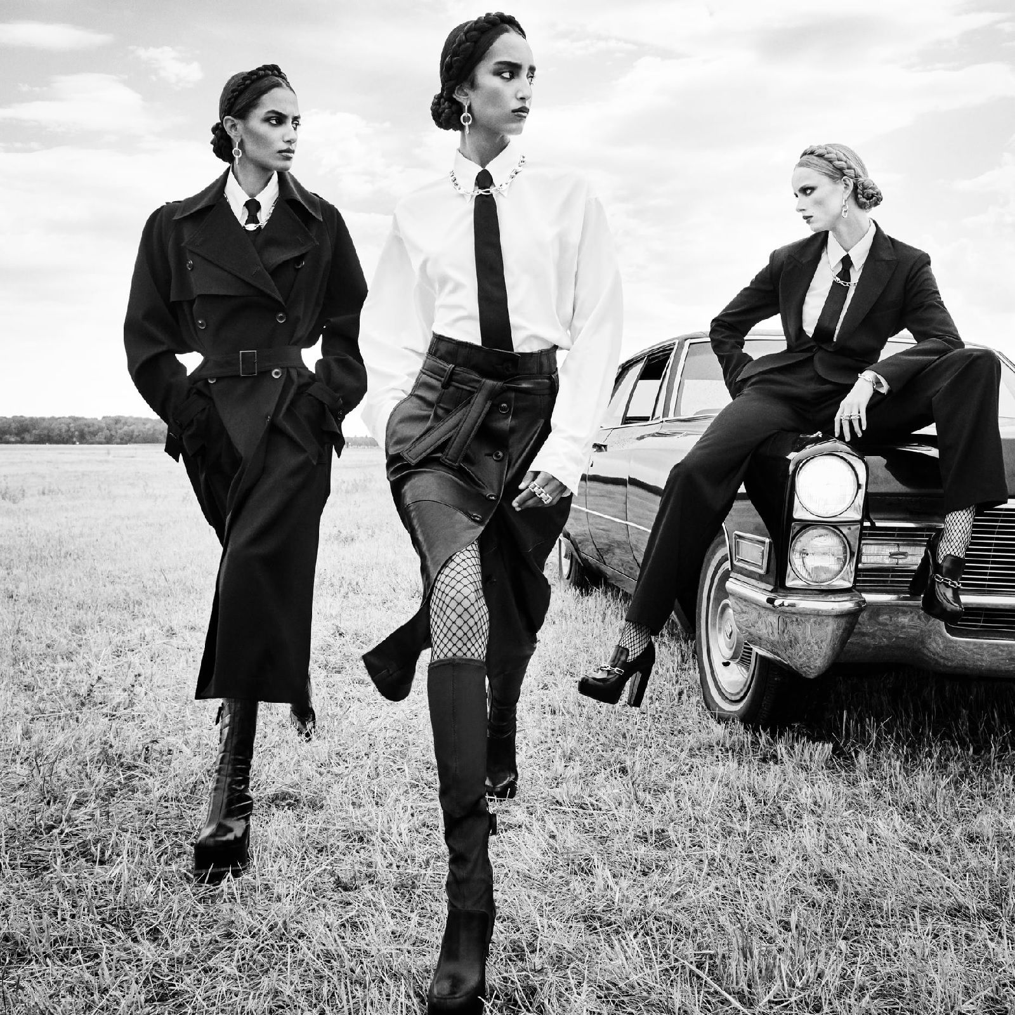

Rianne Van Rompaey, Mona Tougaard, Sacha Quenby e Mika Schneider, shot by Steven Meisel in a series of black and white images, wear the clothes of the new FW20 collection. The traditional tailoring codes, mixed and revisited in a contemporary key, sound almost like a call to action to female empowerment, presented through tailored suits, Oxford shirts matched with vests and cozy coats, tie clips, cufflinks and punk brooches.

### **Zara Spring 2022 Campaign**

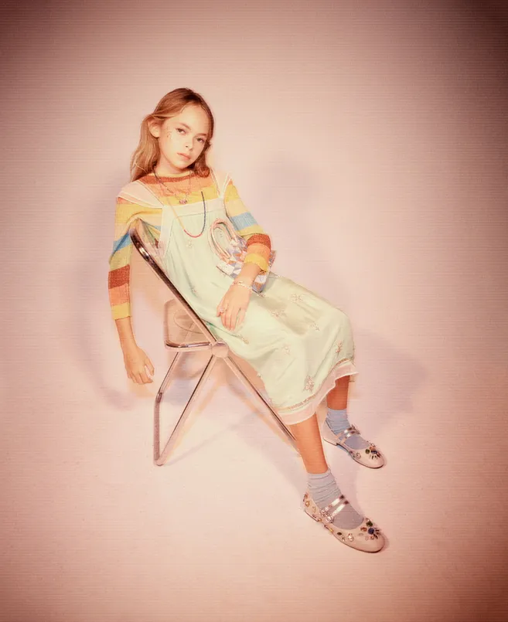

**Image courtesy : Zara**

Zara Studio is the Spanish label's more elevated brand offering (created with stylist Karl Templer), and its campaigns reflect that directional approach. For Spring 2022, Zara Studio enlisted Fabien Baron to creative direct this season's imagery and film. For the men's collection, the brand tapped David Sims to shoot actor Kodi Smit-McPhee, while Steven Meisel photographed the women's line on a variety of faces including models Rianne Van Rompae, Jessica Stam and Edie Campbell. The kid's campaign, meanwhile, is soaked with '70s bohemianism and cool '90s grunge.

**Zara Spring-Summer 2019**

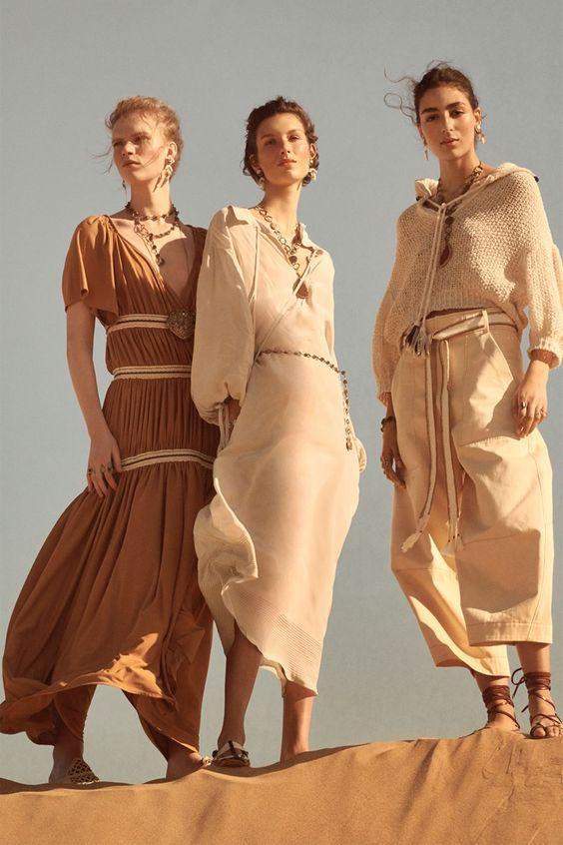

Zara unveils its Spring-Summer 2019 Collection campaign spotlighting new limited-edition styles. The Spanish fashion brand enlists rising stars Nora Attal and others.

**PREMIÈRE Original Edition watch 2022**

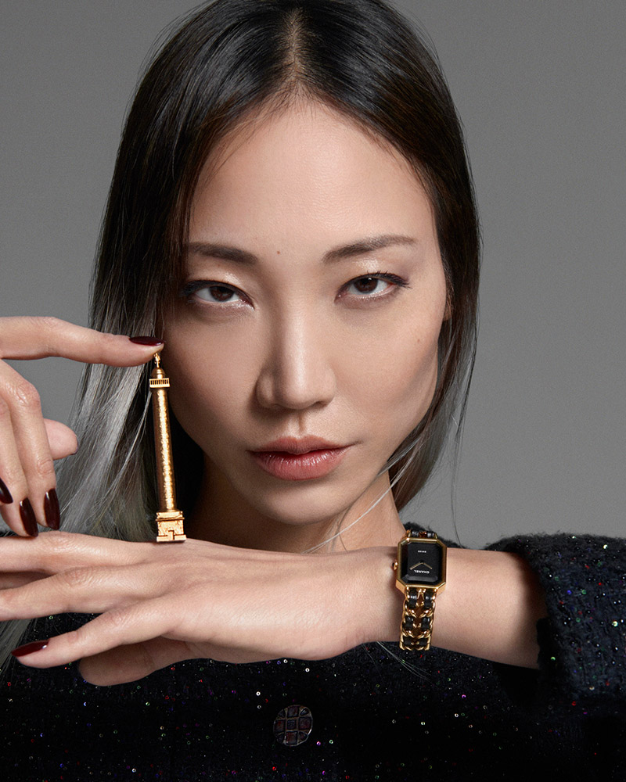

House Ambassador, Korean-American fashion model and artist Soo Joo Park was announced the face of the PREMIÈRE Original Edition watch, launched on October 1st, 2022.

“Wearing the Première watch is like wearing a little of the spirit of CHANEL and of Paris on your wrist. I love the timelessly classic and singularly iconic design that encapsulates the essence of the CHANEL spirit.” — Soo Joo Park

**Chanel Fall Winter 2022 2023 Pre-Collection Campaign**

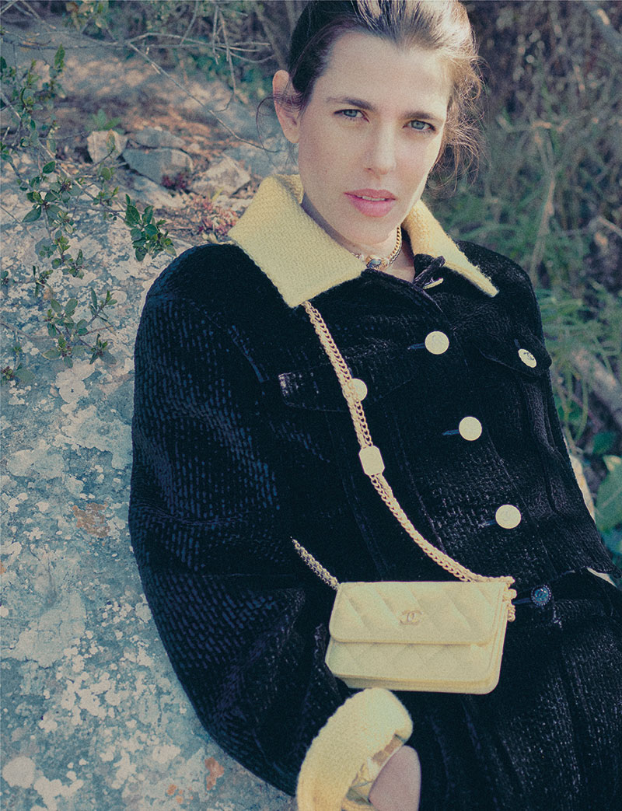

Charlotte Casiraghi is the face of the Chanel Fall-Winter 2022/23 pre-collection campaign, shot by SMITH. More than just a simple collaboration, it was a veritable encounter that took place between the artist and the CHANEL ambassador. Their complicity brings to life a series of photos and a short film that teeters between dream and reality. In the short film, the song Phantom by Sir Alice accompanies a romantic stroll through a landscape shrouded in mystery: a wilderness, an apartment and a pier by the sea. Slow movements, gazes straight at the camera and suspended pauses highlight the key pieces of the collection. The photographs, an extension of this promenade, immortalize the allure of CHANEL in a poetic atmosphere, conducive to both contemplation and reverie.

**Chanel Eyewear, Summer 2022 Collection**

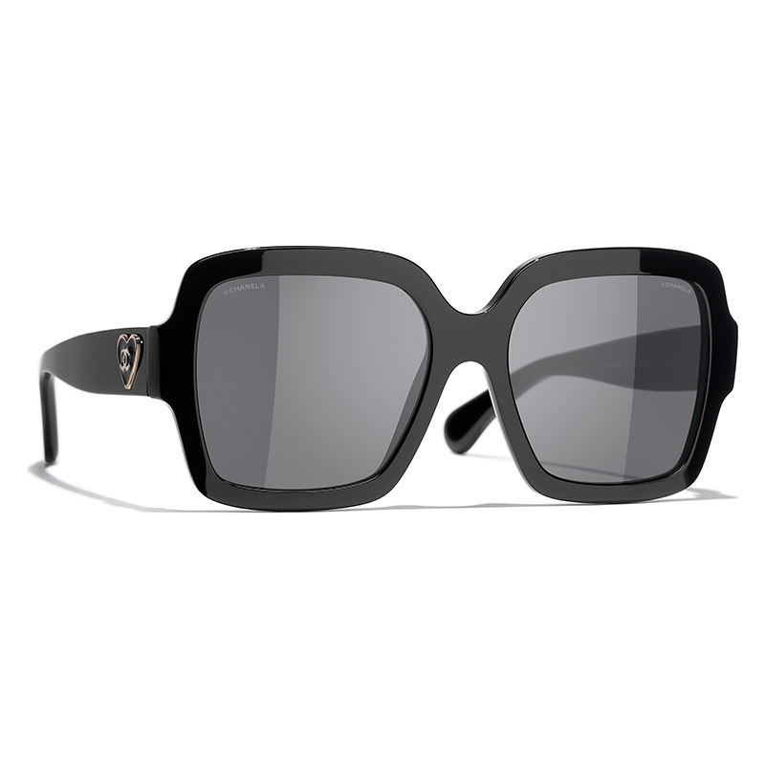

The CHANEL Summer 2022 Eyewear collection brings together three themes: 90s-inspired shields, sunglasses punctuated with charms and sparkling frames with a glamorous spirit, plus a series of new timeless optical frames.

In the spirit of the Spring-Summer 2022 Ready-to-Wear show, CHANEL reinterprets a sunglasses frame symbolic of the 1990s: the shield, available this season in two graphic versions with masculine/feminine accents. These designs come in black acetate or two-tone black and white, navy blue and fuchsia or emerald green. Each one is adorned with wide temples, enhanced by quilting punctuated with mini double Cs or an oversize double C. All details that render these sunglasses a veritable fashion accessory.

**Fashion Calendar**

The calendar year has four seasons: **Spring**, **Summer**, **Fall**, and **Winter**. Typically in the fashion world, these combine into two seasons: Spring/Summer and Fall/Winter. Spring/Summer begins in January and ends in June. Fall/Winter picks up in July and runs through December.

As a fashion designer, when it’s mid-season of Spring/Summer you should be finalizing and close to receiving your Fall/Winter collection. Spring-summer collections are shown to the press at Fashion Week in September for the following summer, while AW collections are shown in February for the following winter.

Fashion Week informs the trends for the season, so collections must be shown early.

Retail buyers need time to view the collections and decide which pieces to go with, then designers need time to manufacture the orders. Fashion editors also need time to select samples and shoot editorials for the season, informing their readers of the trends before they hit stores.

**Resort** and **Pre-Fall** collections don’t have their own Fashion Weeks, so brands often shoot them independently and send them out to press. A seasonless trend has emerged during fashion week for the past few years. More fashion brands have been blending seasons together in their collections.

We’ve seen some unexpected seasonal products and trends on the catwalk—boots in spring and lightweight sleeveless pieces in winter.

While a few fashion traditionalists believe seasonless fashion is sinful, the approach makes sense. Especially with climate change, the conventional seasonal model is behind the times.

Brands such as Ralph Lauren, Tommy Hilfiger, Prada, and Tom Ford are gradually shifting away from trends to showcase timeless pieces on the catwalk during the most recent shows.

Brands are also becoming more aware of the conscious consumption of their customers and global accessibility. A seasonless approach allows customers to buy clothes all year round, no matter where they are in the world.